ISO

appISO.py (port=5001)

'/tod/api/v1.0/ISO', methods=['GET', 'PUT']

UtilityID, PredictedLoad.Hour1 to Hour24

putISO.py, getISO.py

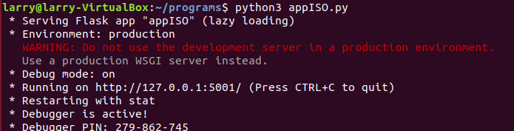

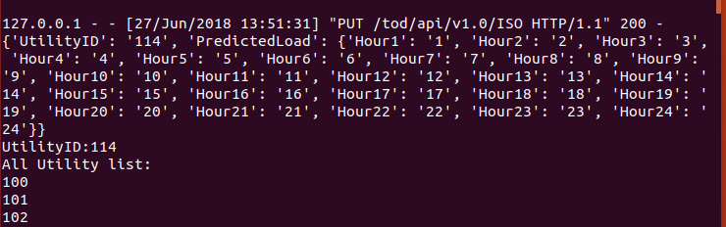

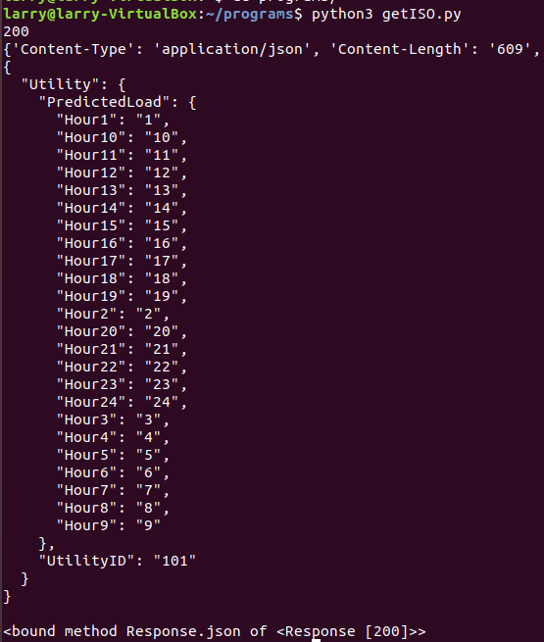

Utility

appUtility.py (port=5002)

'/tod/api/v1.0/Utility', methods=['GET', 'PUT']

'/tod/api/v1.0/Utilityall', methods=['GET']

AggregatorID, NumberofHomes, PredictedLoad.Hour1 to Hour24, DesiredLoad.Hour1 to Hour24

putUtility.py, getUtility.py, getUtilityAll.py

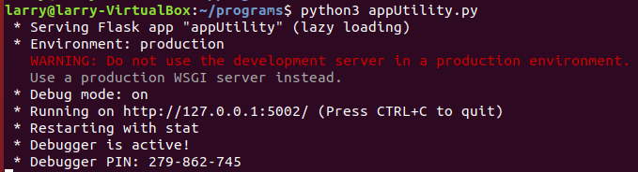

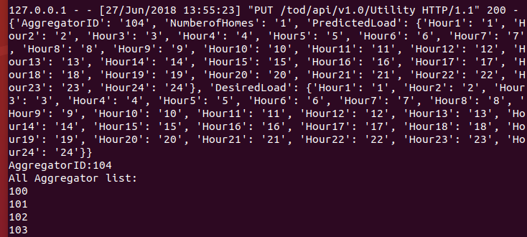

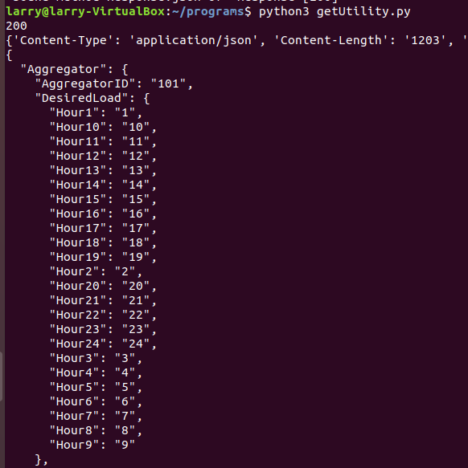

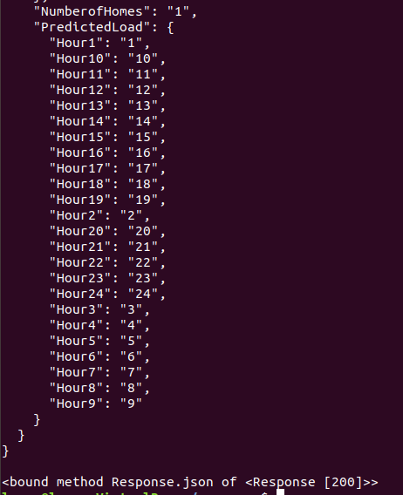

Aggregator

appAggregator.py (port=5003)

'/tod/api/v1.0/Aggregator', methods=['GET', 'PUT']

'/tod/api/v1.0/Aggregatorall', methods=['GET']

HomeID, NumberofDevices, Devicetye. Devicetype1, PredictedLoad.Hour1 to Hour24, Price.Hour1 to Hour24, DesiredLoad.Hour1 to Hour24

putAggregator.py, getAggregator.py, getAggregatorAll.py

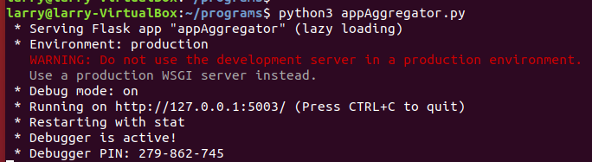

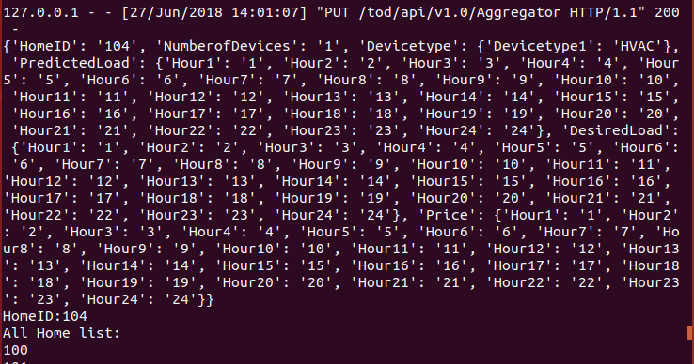

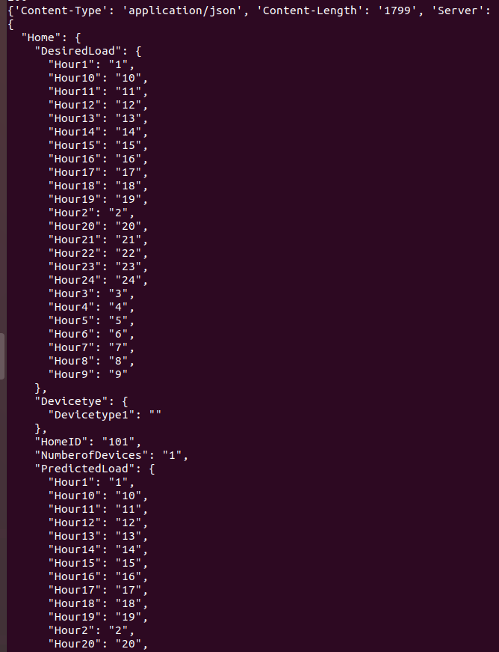

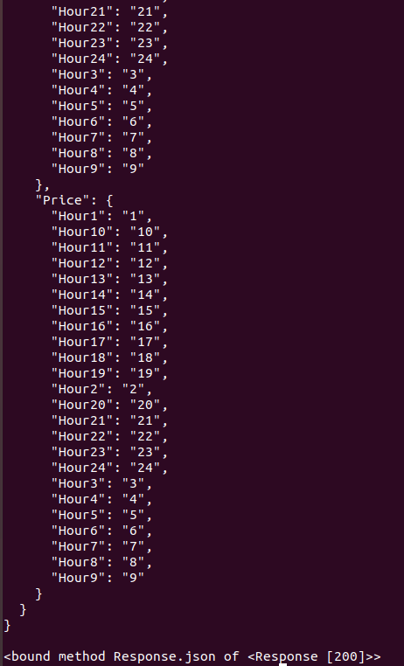

Home

appHome.py (port=5000)

'/tod/api/v1.0/HVAC', methods=['GET', 'PUT']

DeviceID, DeviceType, DeviceConfiguration, HVAC, …

'/tod/api/v1.0/WH', methods=['GET', 'PUT']

DeviceID, DeviceType, DeviceConfiguration, WH, …

'/tod/api/v1.0/ES', methods=['GET', 'PUT']

DeviceID, DeviceType, DeviceConfiguration, ES, …

'/tod/api/v1.0/Solar', methods=['GET', 'PUT']

DeviceID, DeviceType, DeviceConfiguration, Solar, …

putHome.py, getHome.py

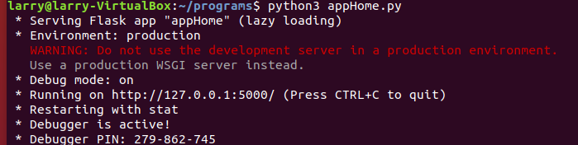

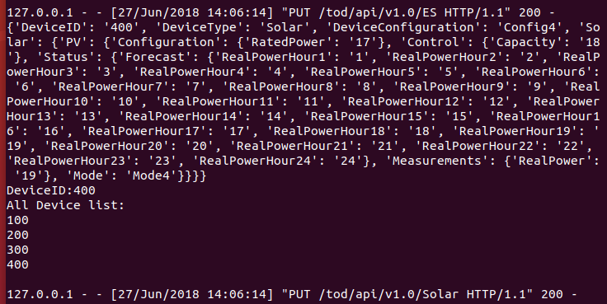

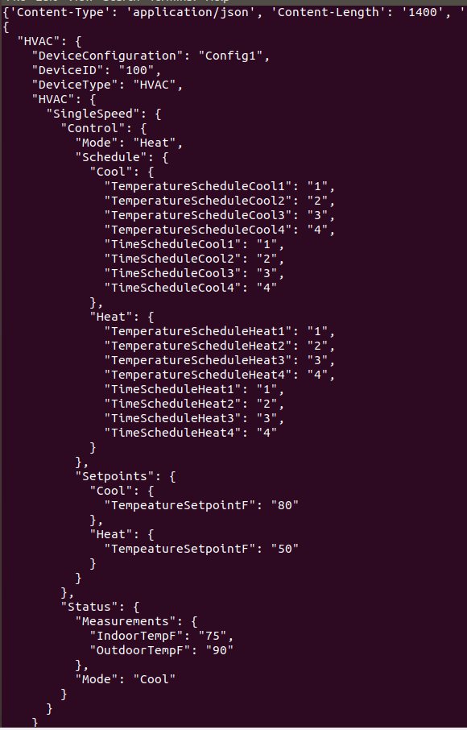

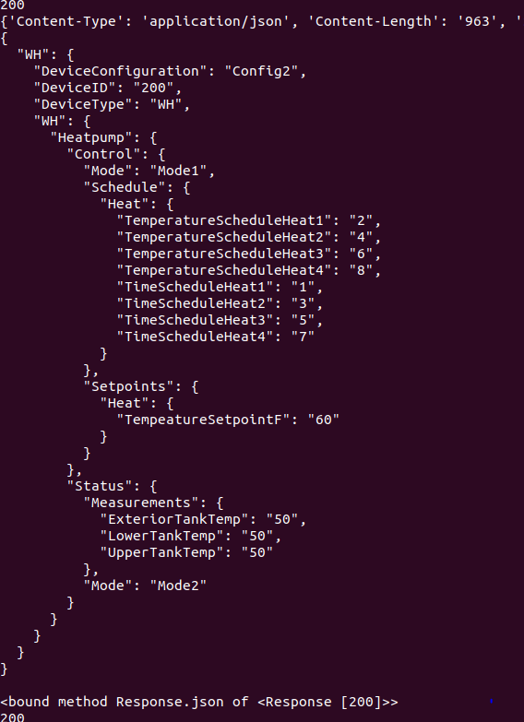

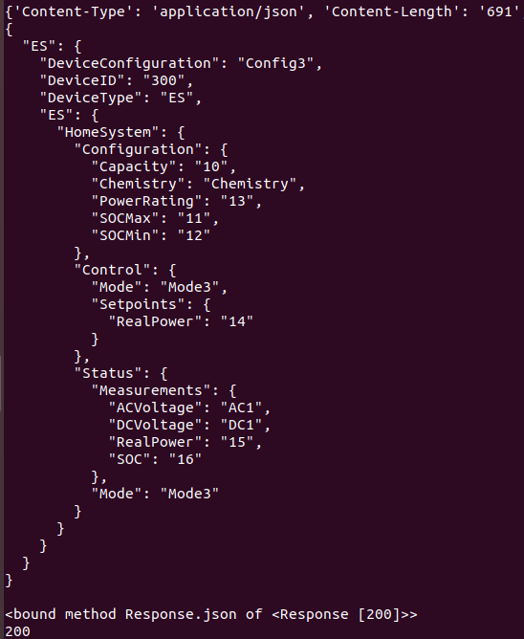

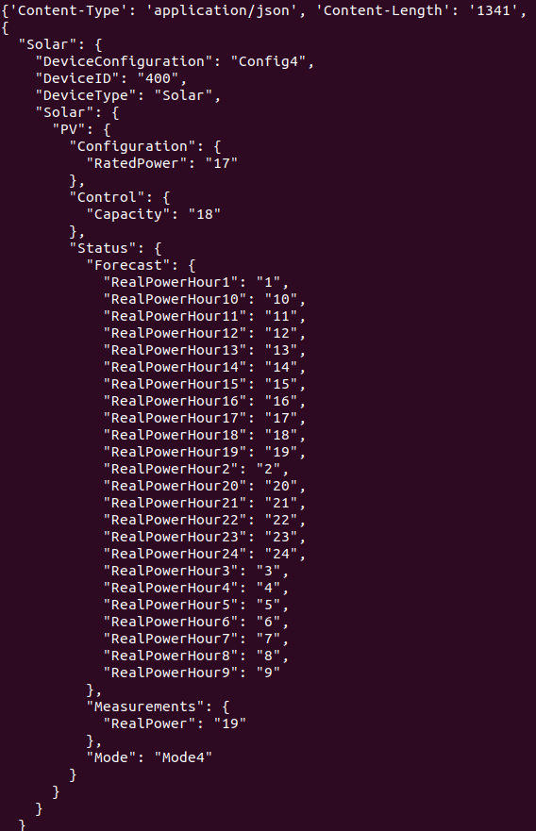

Oracle VM VirtualBox Manager

lsb_release -sd

Ubuntu 18.04 LTS

python3 -version

Python 3.6.5

Dependencies

sudo apt-get install python3-pip

pip3 install Flask

sudo apt-get update

sudo apt-get install git-core

git clone <https://github.com/requests/requests.git>

cd requests

pip3 install .